Final Project

By

Bhawandeep Singh

Table of Contents

Project Proposal 3

Goals and Objectives 3

Project Scope 3

Project Specifications 3

Target Audience 3

Project Deliverables 4

Resource Requirements 4

Project Tasks and Milestones 4

Project Assumptions 5

Project Report 5

Detail Design 6

Home Page 6

Registration Page 6

Login Page 7

All Food Categories Admin View 7

Food Recipes Page Admin View 8

All Food Recipes Visitor View 8

All Food Categories Visitor View 9

Food Recipes Details Page Visitor View 9

Project Testing 10

User Manual 10

Summary 10

System Configuration 10

User Access Levels 10

# 

# Project Proposal

## Goals and Objectives

The main aim of the project is to implement an online web application named “Food Recipes”. The application help people to find different-different food recipes from different states / continents of India. In this application there are two types of users- admin and registered visitor. Admin has different functionalities as compare to registered visitor. Admin can add, edit, delete and check details of all food recipes. Admin can edit, delete and check details of the food recipes reviews. Also, admin can delete and access details of the reviews and food categories.

## Project Scope

The scope of this project is to implement an app named “Food Recipes” with the help of which user can find any food recipe and can review them. The duration of the project is 20 working days which is equals to 4 weeks.

## Project Specifications

* Admin login/logout
* Add, edit, delete and check details of food recipes by admin.
* Admin can delete, edit and check food categories.
* Admin can delete and check reviews for application.
* Admin can register new admins.
* Registered Visitor can login/logout.
* New Visitor can register.
* Visitor can review the food recipe details.

## Target Audience

The target audience for this project is the food lover people who would like to enhance their skills and taste in food from all the regions of country. The age can go from 18 plus to 70 plus.

## Project Deliverables

The deliverables of the project are:

|  |  |
| --- | --- |
| **Deliverable** | **Description** |
| Final Report | This will be the final report of the project. |
| Coding | The executable code of the project will go under this. |
| Documentation | This portrays the documentation of the project. |
| Testing | All the test details will be covered in this part. |

## Resource Requirements

* Windows Operating System.
* Microsoft word for documentation.
* Asp.net MVC Framework
* 64-bit Processor and 4 GB or more RAM
* Identity framework- ASP

## Project Tasks and Milestones

|  |  |  |  |  |
| --- | --- | --- | --- | --- |
| **Tasks** | **Week-1** | **Week-2** | **Week-3** | **Week-4** |
| Brainstorming and analysis |  |  |  |  |
| Planning and initial meeting Project Proposal document. |  |  |  |  |
| Database Design and UI Design |  |  |  |  |
| Identity framework implementation |  |  |  |  |
| Coding for admin and reporter |  |  |  |  |
| Testing |  |  |  |  |
| Final Documentation and closing |  |  |  |  |

## Project Assumptions

Following are the assumption made while implementing the project:

* One admin and registered visitor will be registered by default.
* Application will be free and open source.

# Project Report

#### Functional and Non-Functional

|  |  |
| --- | --- |
| Users | Functional |
| Admin | * Login/logout * Register new admins * Admin can add, edit, delete, check details for food categories. * Admin can edit, delete and check details for food recipes. * Admin can delete and check details for the reviews on recipes. |
| Customer | * Can view details of food categories, recipes and reviews. * Can review the food recipes * New customers can register for free. * Login using valid credentials |
|  | Non- Functional |
|  | * High speed * Fast Loading time * High performance and security * All browsers compatibility. |

## Detail Design

### Home Page

The Home page of the application. On navigation bar options are- Home, Food Categories, Food Recipes, Reviews, Register, Login.

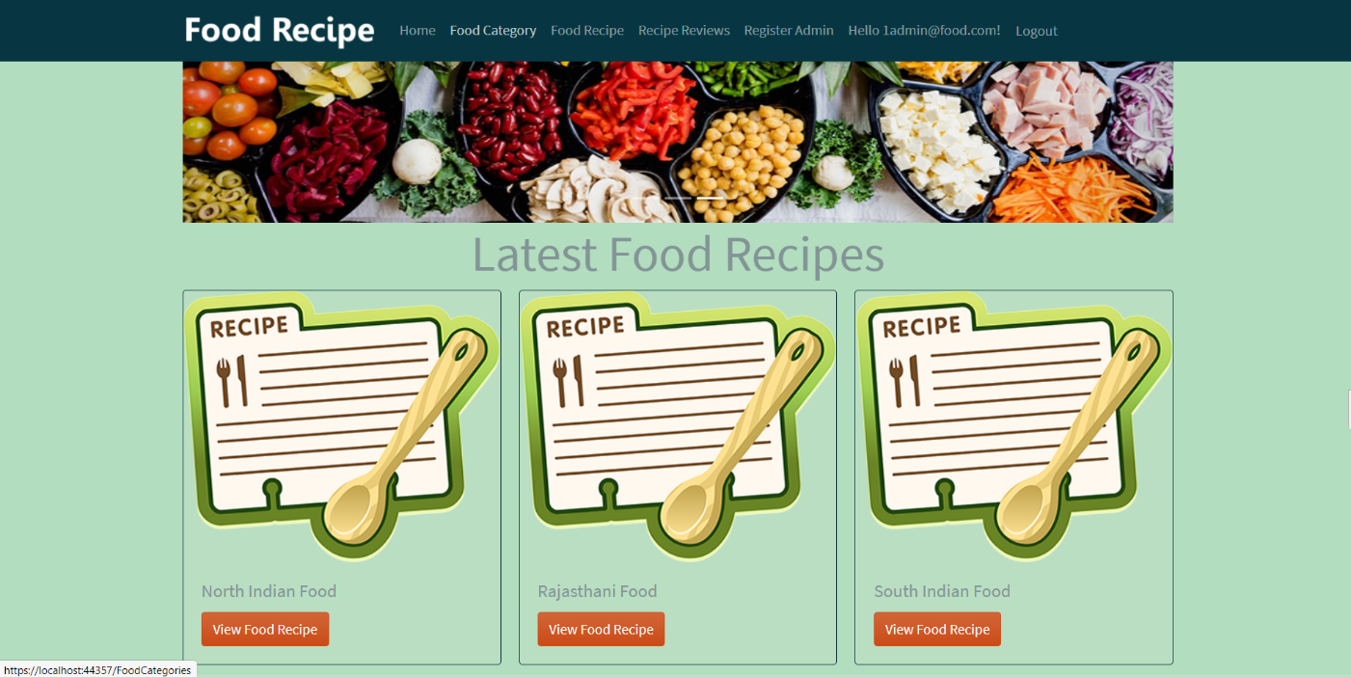

### Registration Page

With the help of this page, new registered visitor can sign up for the app

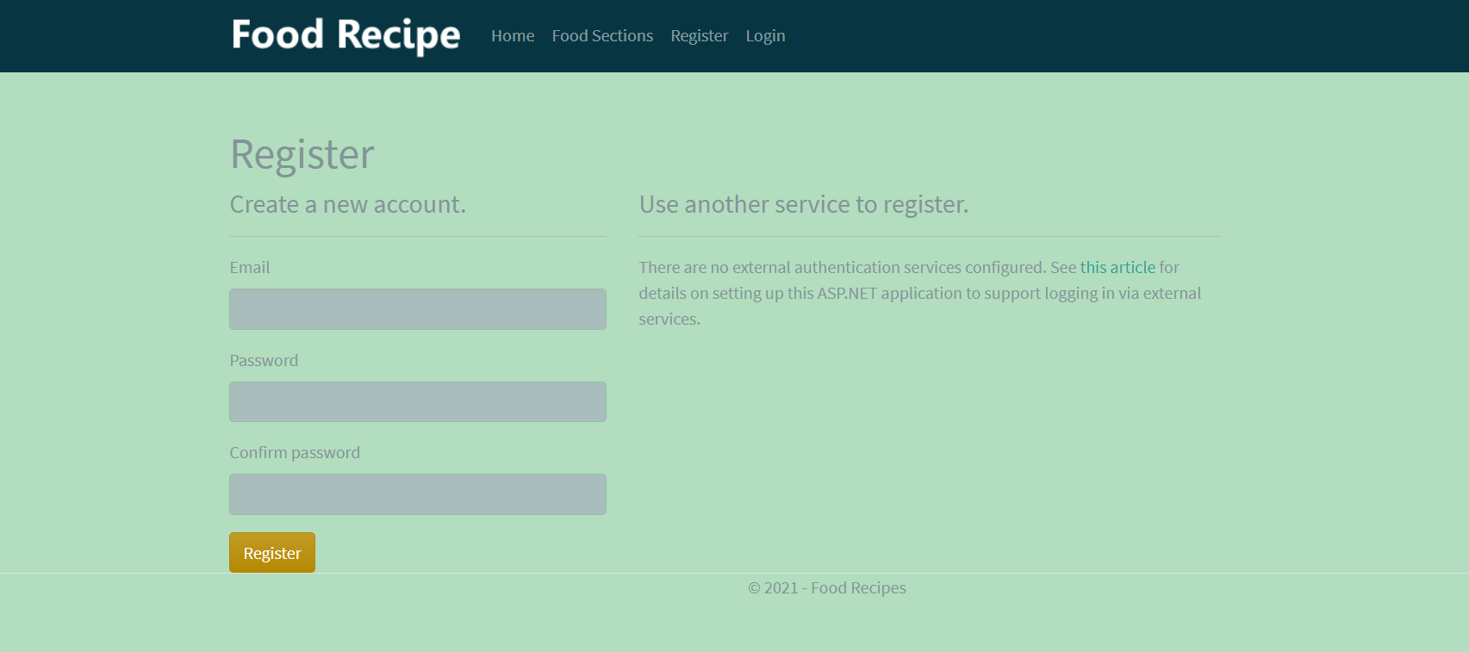

### Login Page

With the help of this page, registered visitor and admin can login to the application using their valid credentials.

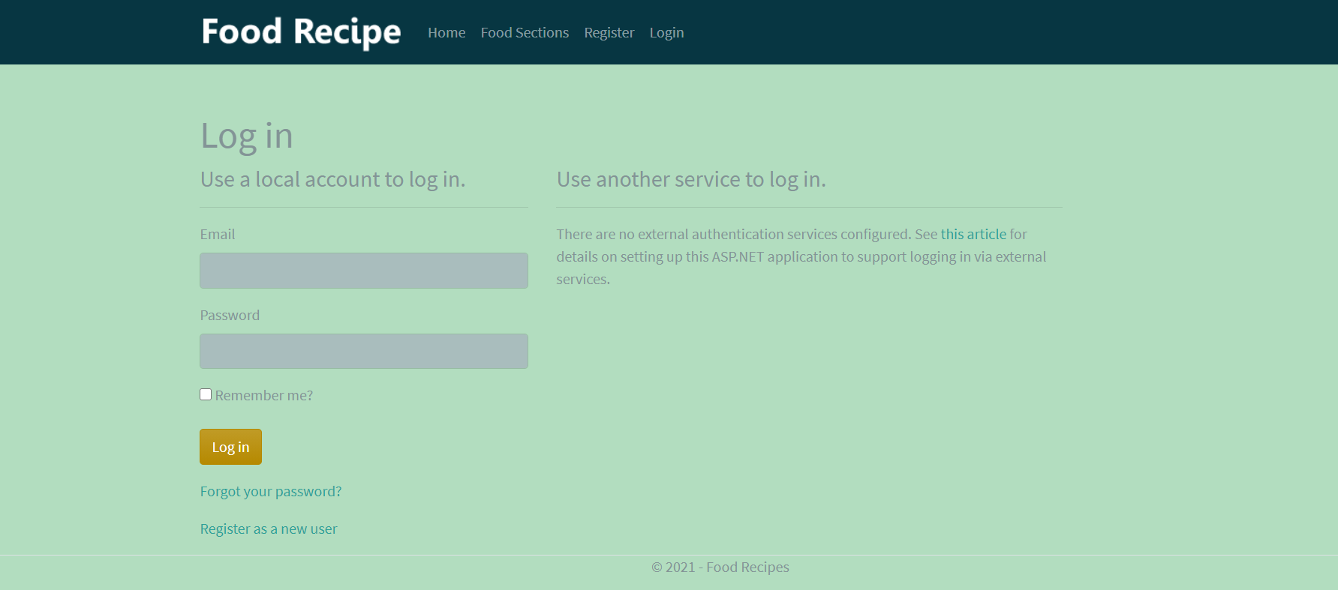

### All Food Categories Admin View

This page highlights all the food categories available on the application. Admin can add new category, edit, delete and check details of the existing ones.

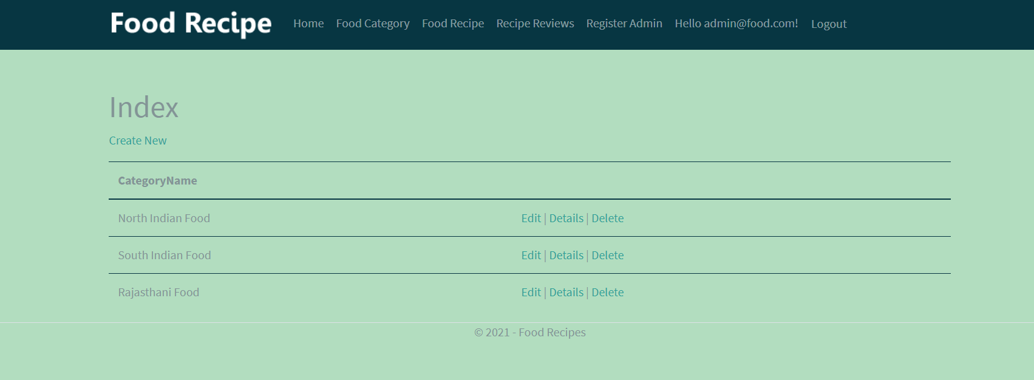

### Food Recipes Page Admin View

With the help of this page admin can manage the food recipes by editing, deleting and checking their details.

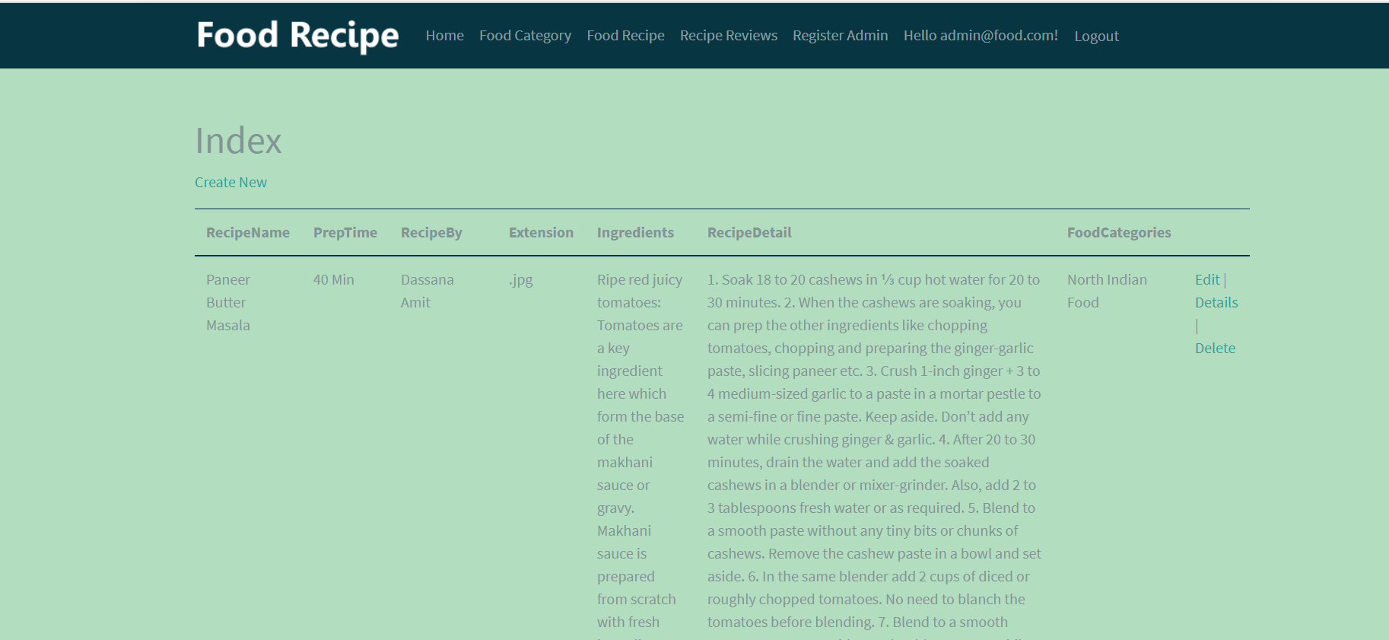

### Food Recipes Page Visitor View

With the help of this page Visitor can view food recipes.

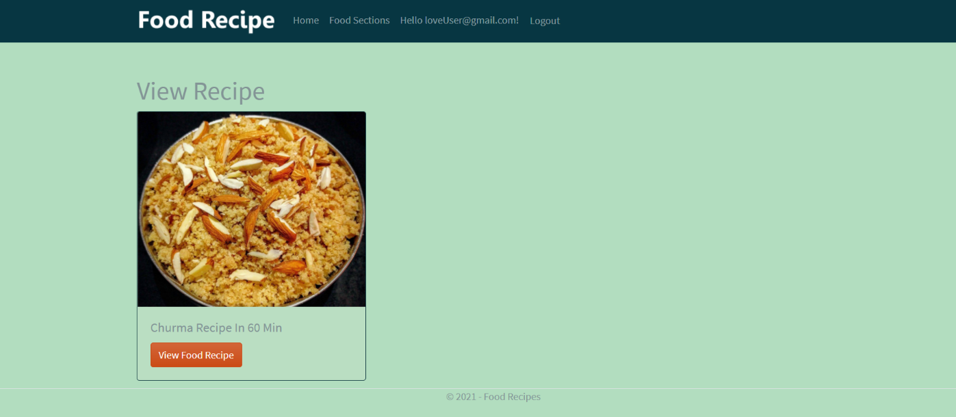

### All Food Categories Visitor View

With the help of this page visitor can check the details of the food categories and their recipes.

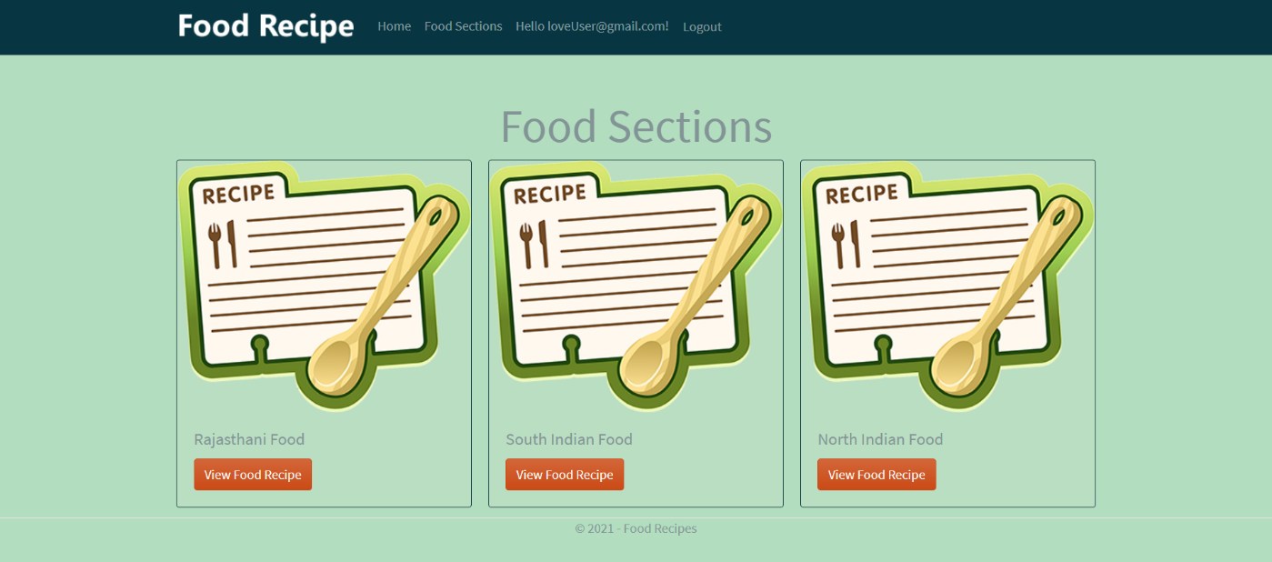

### Food Recipe Details Page Customer View

This page shows the food recipe details.

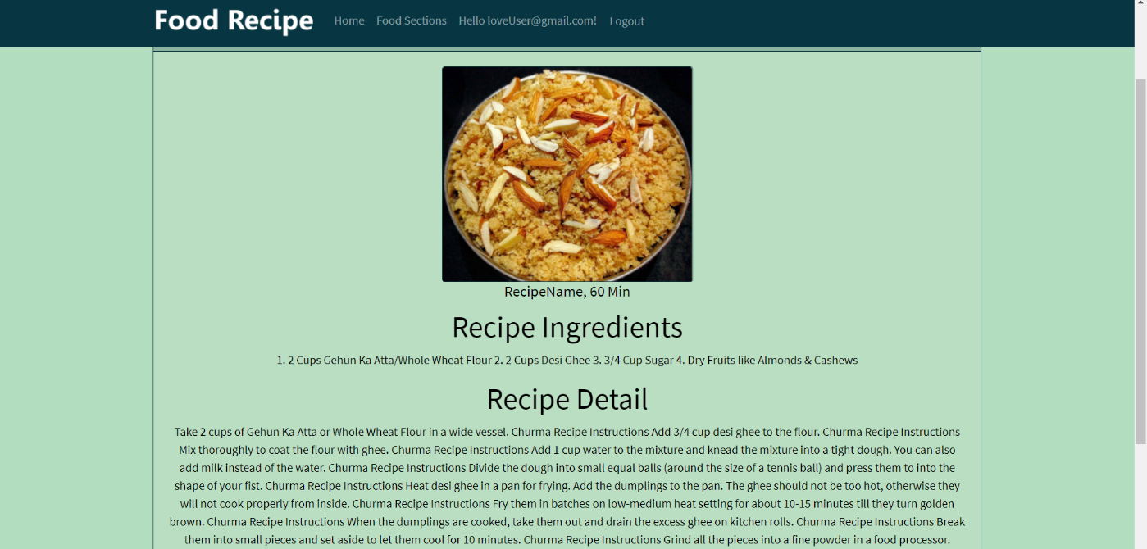

## Project Testing

The testing file for usability testing is attached as [usability test.xlsx](usability%20test.xlsx)

# User Manual

The main purpose of the application Food Recipe is to help people to find recipe of their choice based upon other visitor review. In this application there are two types of users- admin and registered user or visitor customer. Admin has different functionalities as compare to customers. Admin can add, edit, delete and check details of food categories, user’s reviews. Admin can edit, delete and check details of the categories, food recipes and user’s reviews. Also, admin can delete, and access details of the review made by the visitor.

## Summary

### System Configuration

This app will be useful to for narrating food preparation recipes in presentable format.

### User Access Levels

Only registered users can access the features of this application.

* **Admin:** Admin has full access of the app can register new admins.
* **Registered Visitor:** New visitor can register and existing can login using their own credentials. They have limited access.